1. Run xampp control panel
2. Start apache and mysql
3. Go to xampp folder
4. Go to htdocs folder
5. Create folder internshala
6. Paste the zip files blood management system inside the internshala
7. Go to localhost/phpmyadmin after typing in the url address preferred chrome
8. Create the database internshala_bms
9. Upload sql file inside the database (internshala_bms.sql)

**Xampp**

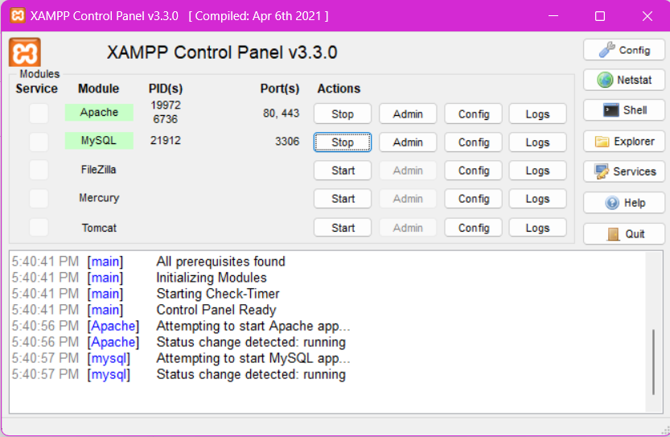

**Step 1 and step 2**

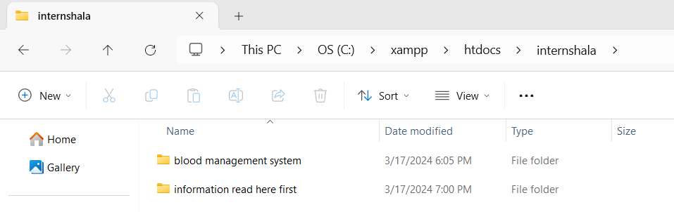

**Step 3 to 6**

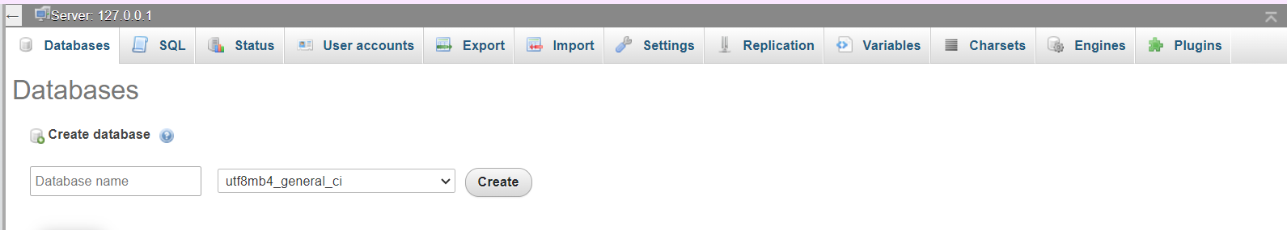

**Step 8**

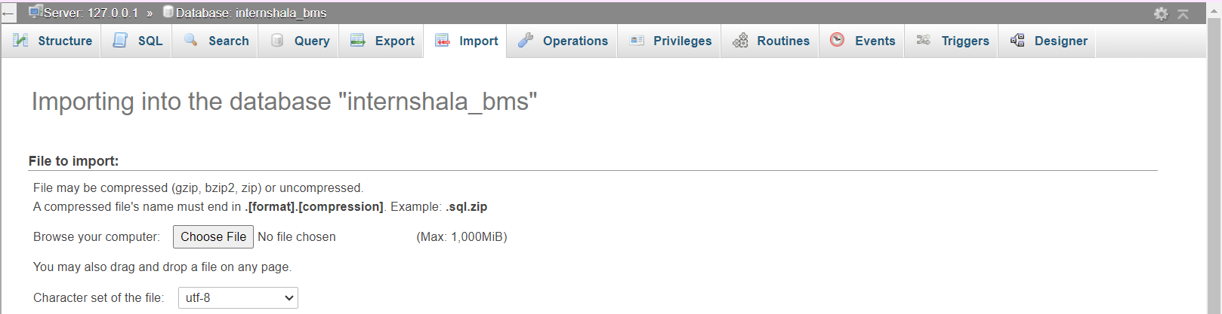

**Step 9**

**Homepage/ mainpage**

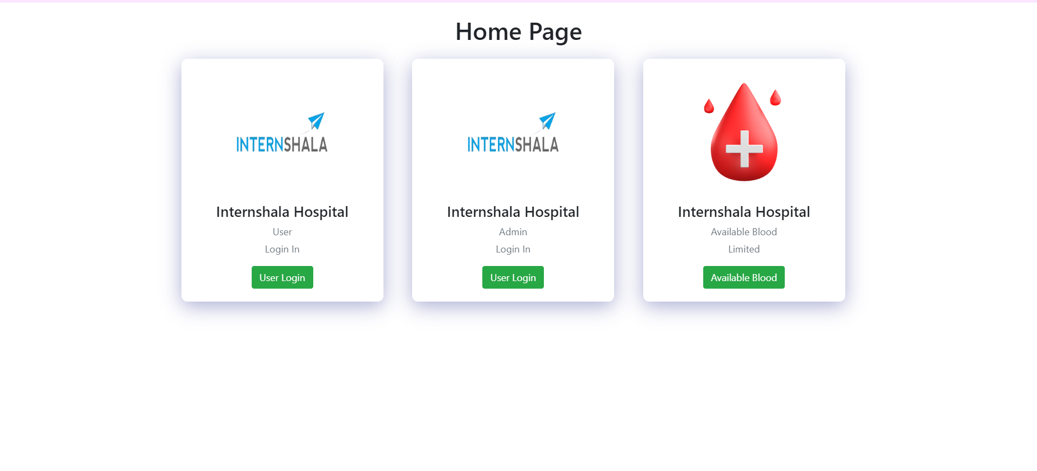

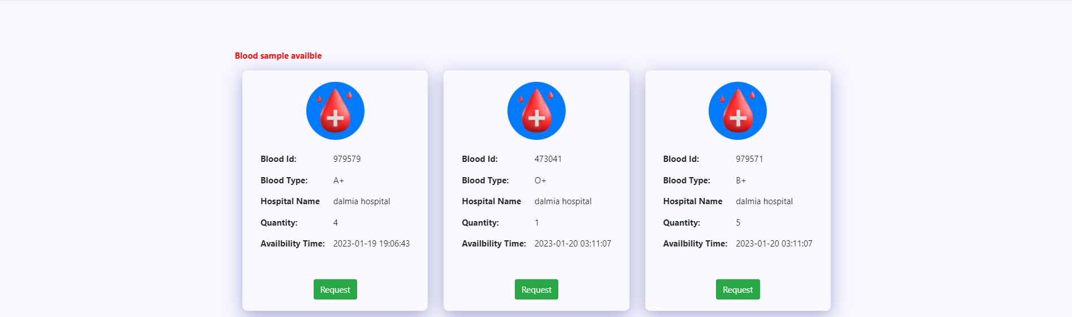

See available sample without login

**User receiver**

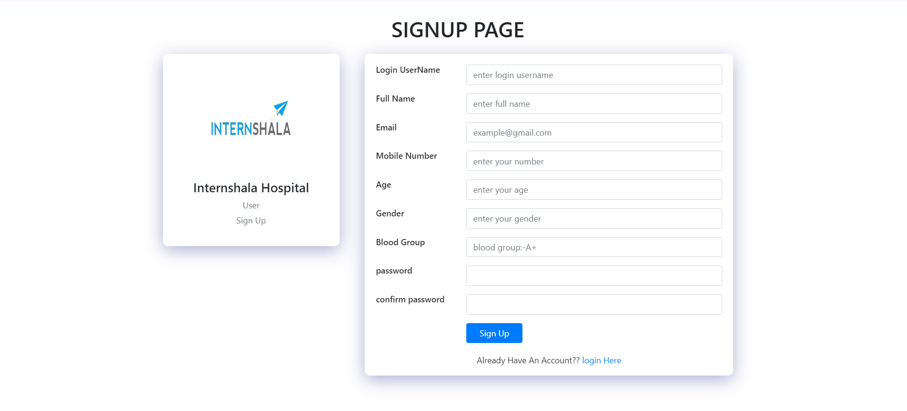

**Signup page**

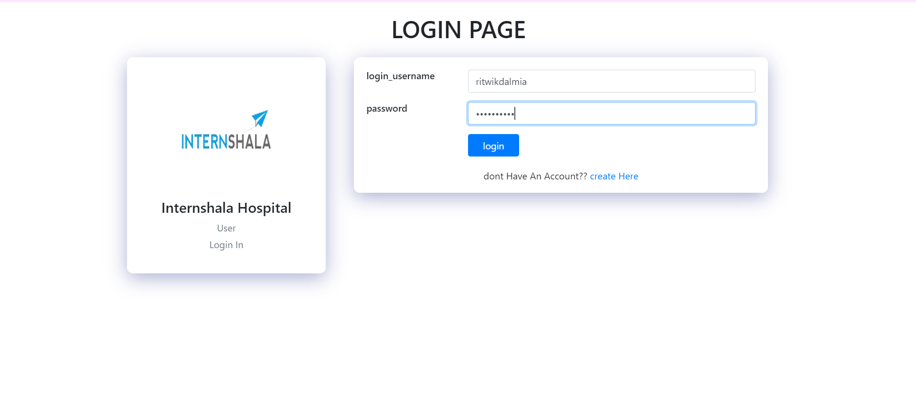

**Login.php page**

**username**

ritwikdalmia

**password**

Bittoo123!

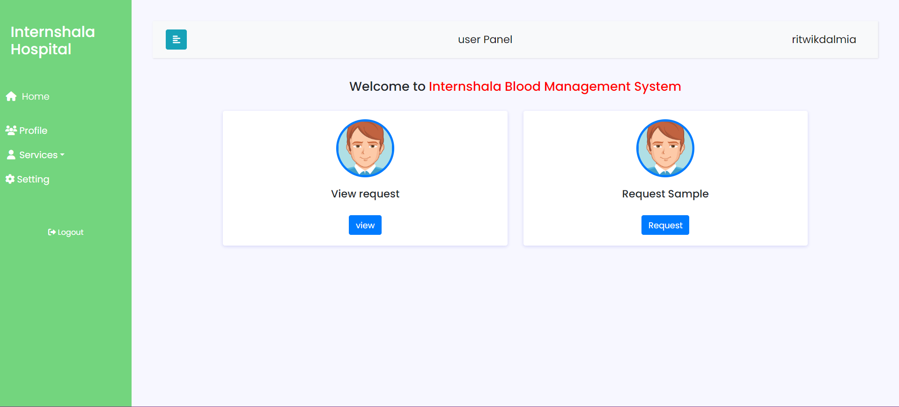

**Dashboard after login**

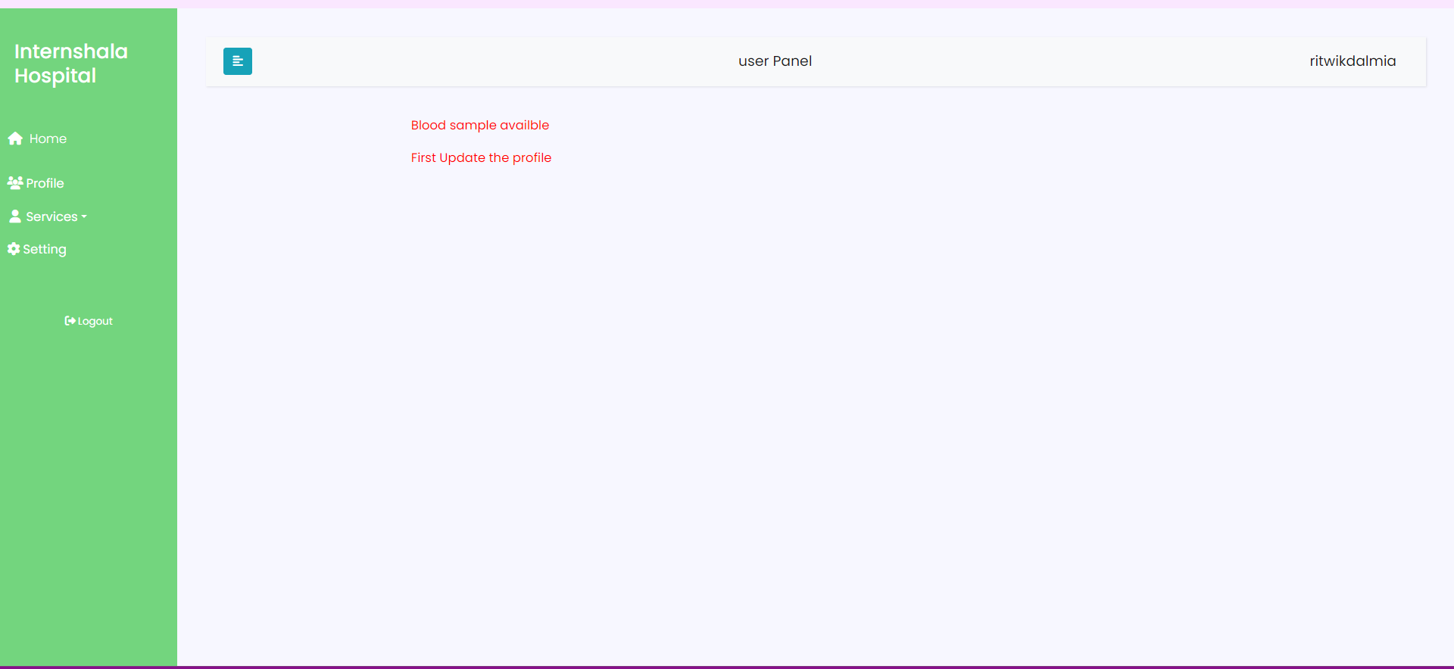

**View_request.php (cant see the blood sample without completing the profile)**

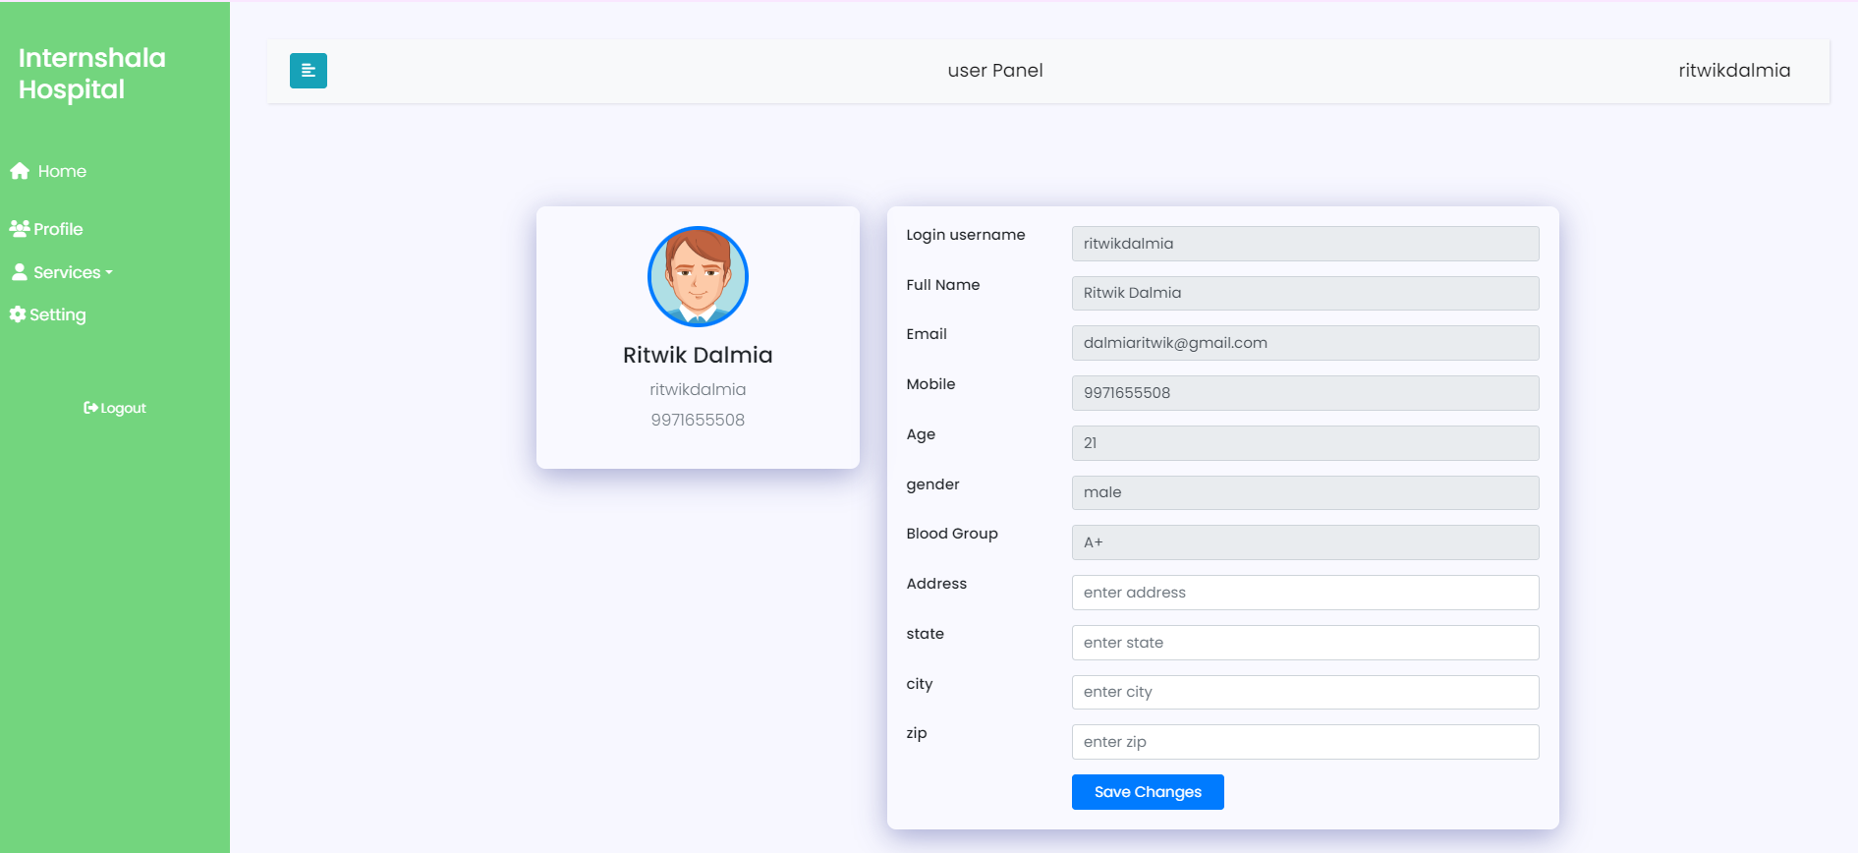

**Profile.php (not completed)**

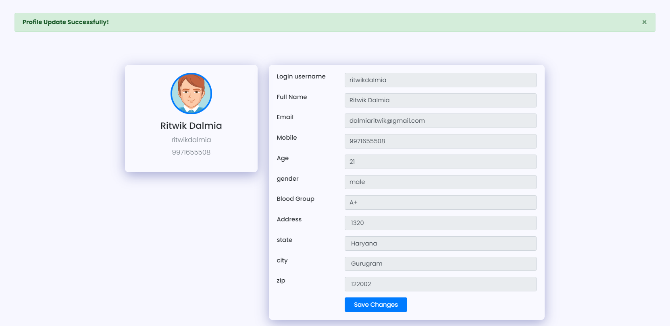

**Profile.php (updated)**

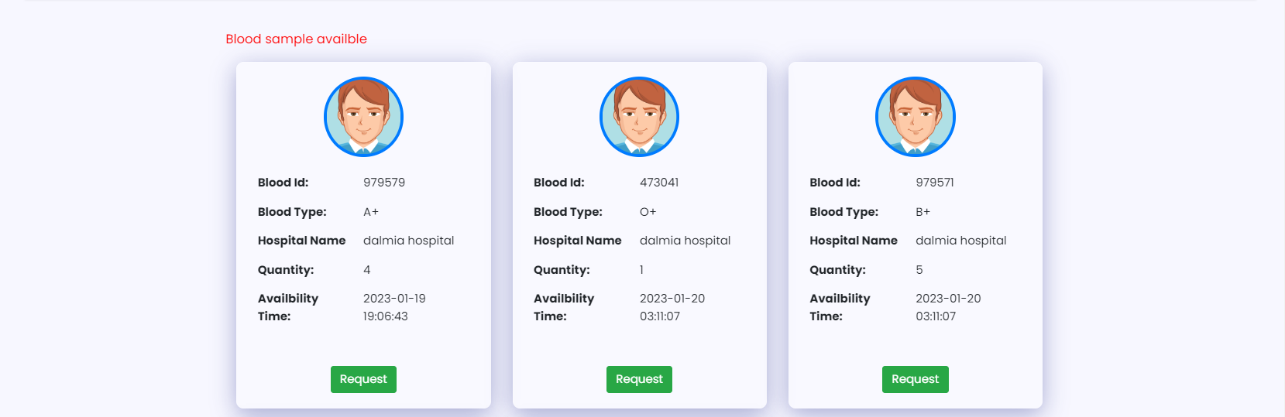



**View_request.php (can see the blood sample after completing the profile)**

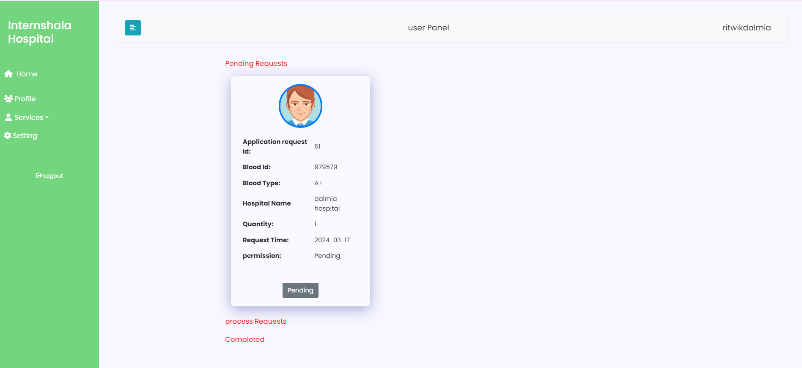

**View_application_request.php (can see the requested blood application here)**

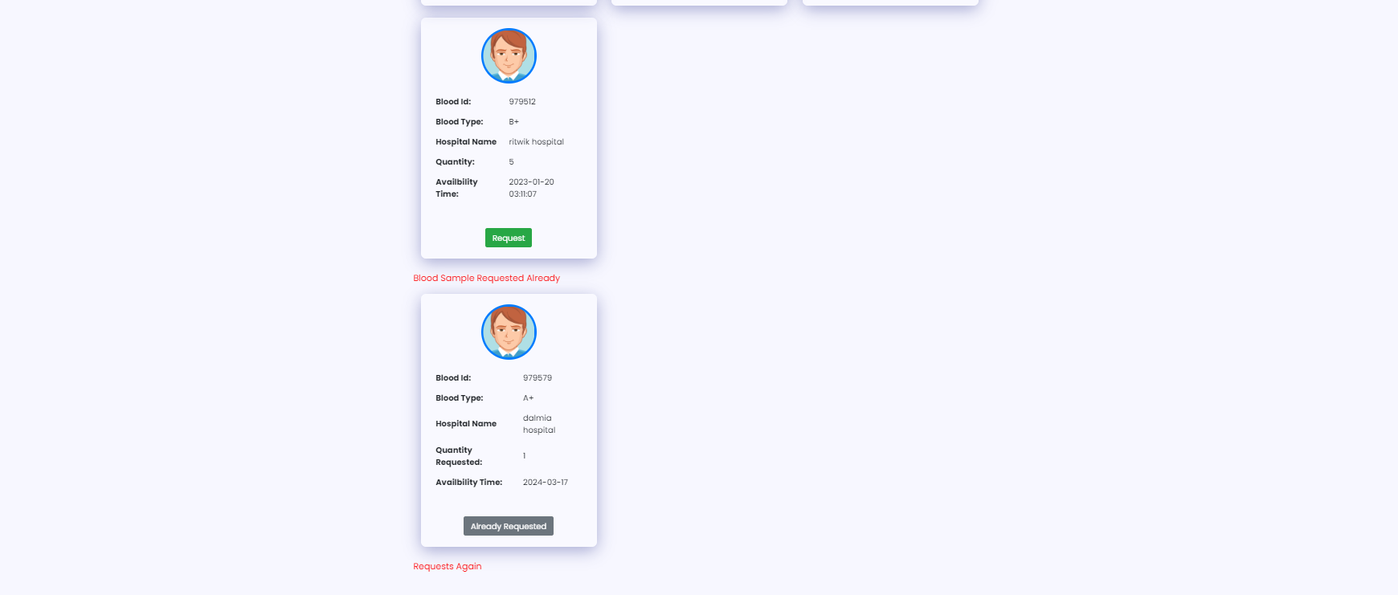

**View_request.php (can see the blood IN blood sample requested already)**

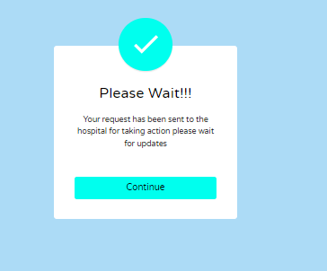

**After clicking on already registered**

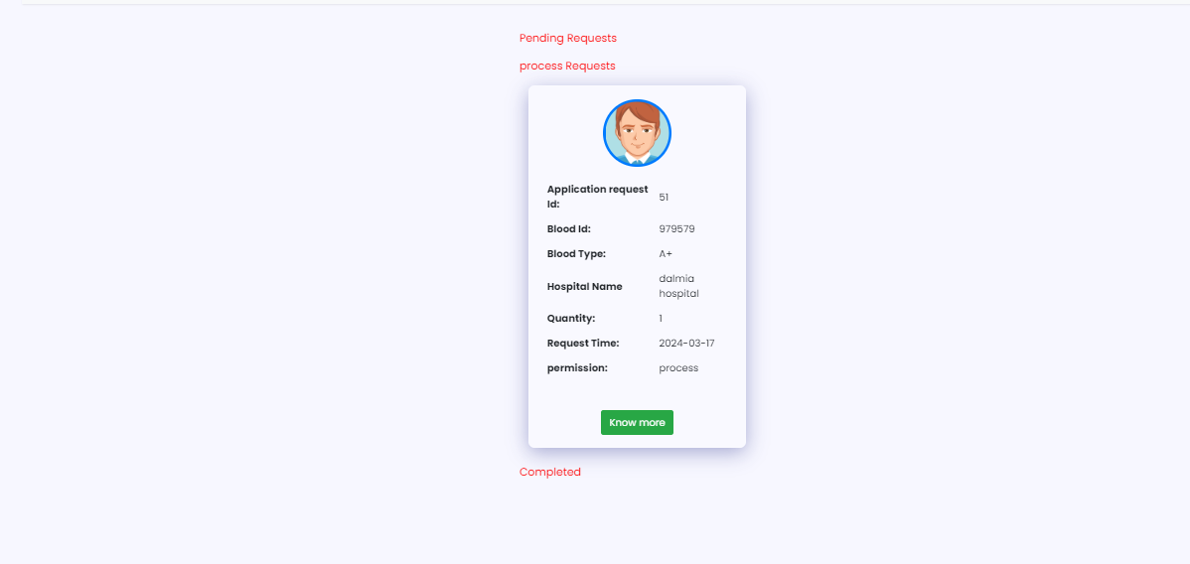

**View_application_request.php (can see the requested blood application here in process)**

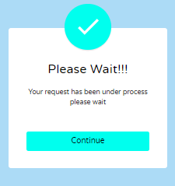

**After clicking on know more**

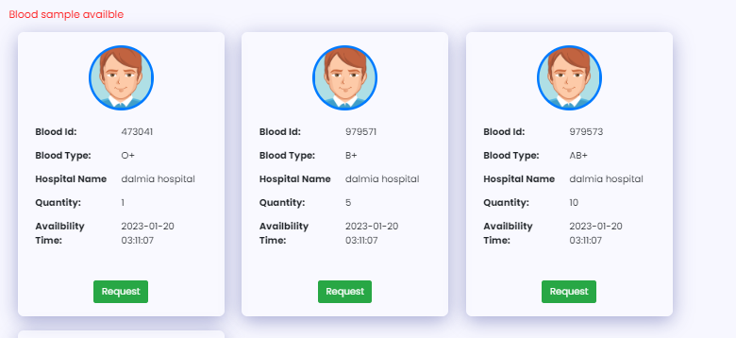

**Trying to request the another blood type from same hospital for example O+**

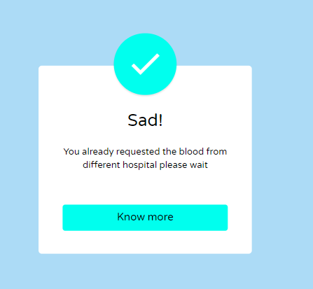

**Getting the alert (different or same hospital)**

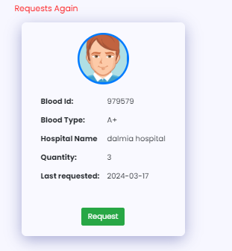

**requested blood type from same hospital has been done once for example A+**

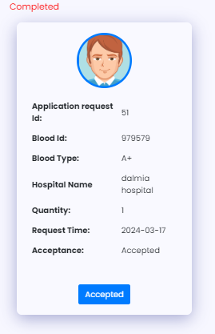

**View_application_request.php (can see the requested blood application here in completed**

**With acceptance Accepted or rejected)**

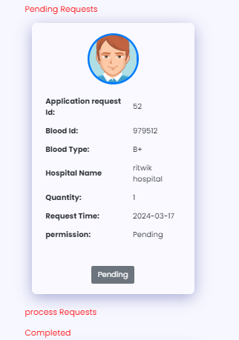

**View_application_request.php (can see the requested blood B+)**

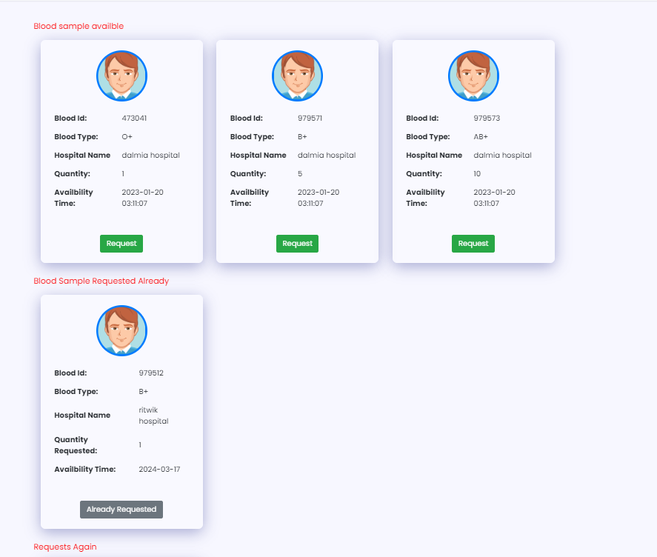

**Trying to request blood group B+ again from dalmia hospital**

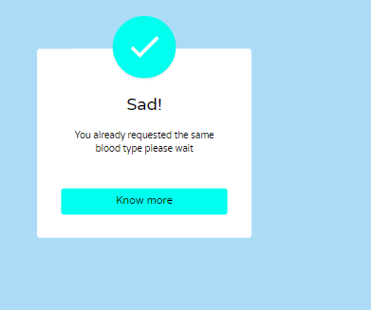

**Already requested same blood group**

**Admin screen shot**

**username 1 / username 2**

ritwik1234 / ritwik4321

**password**

Bittoo123!

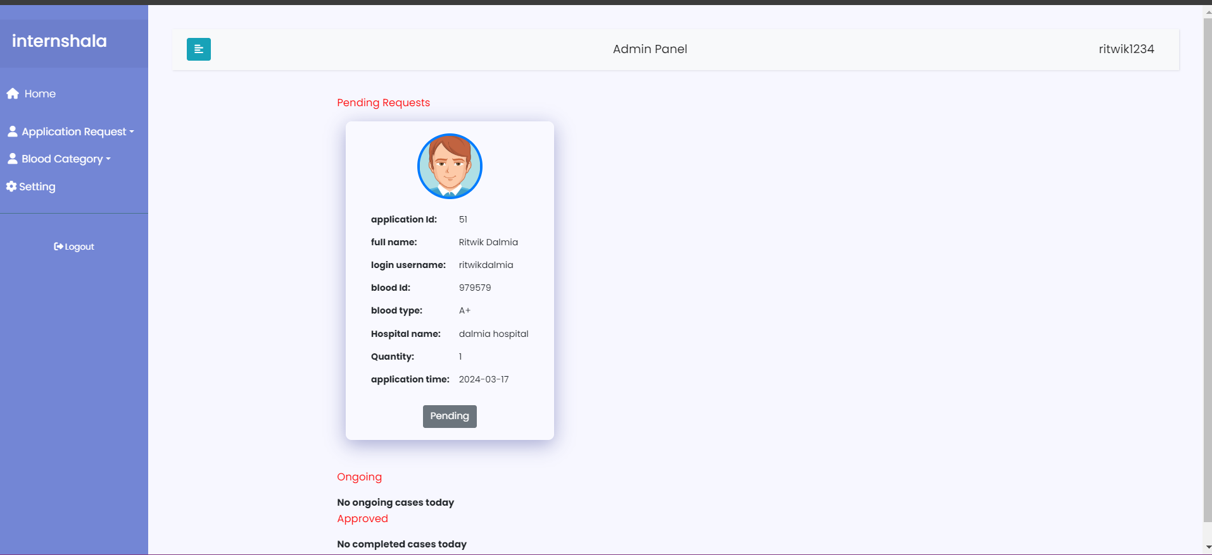

**Manage_request.php**

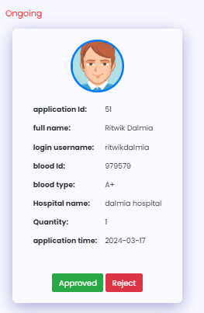

**In process**

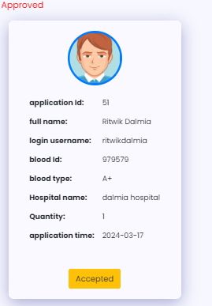

**Accepted**

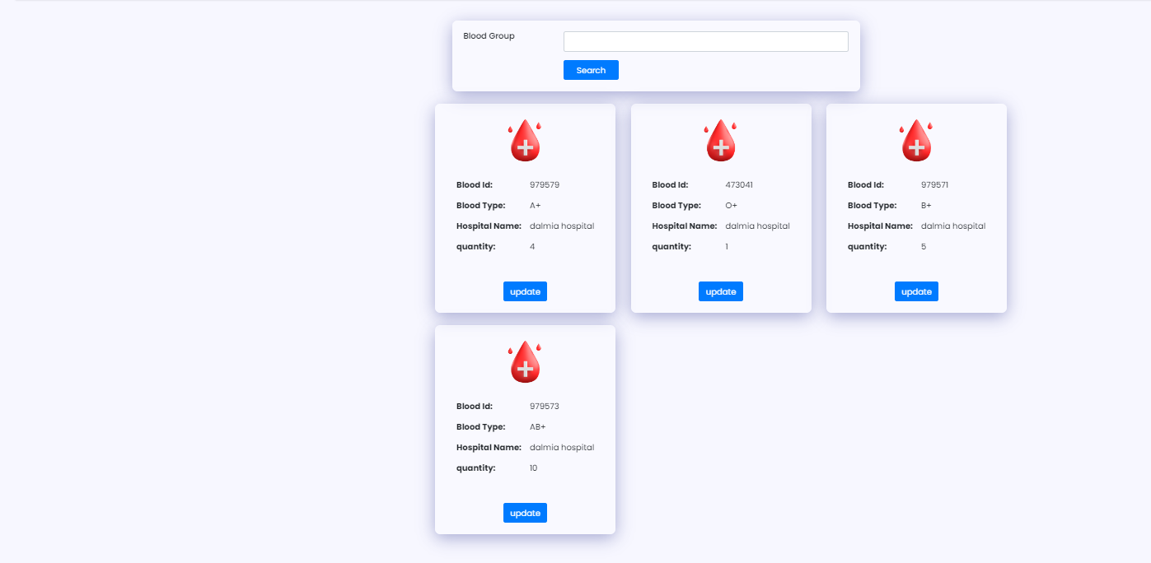

**Blood Group Stock available**

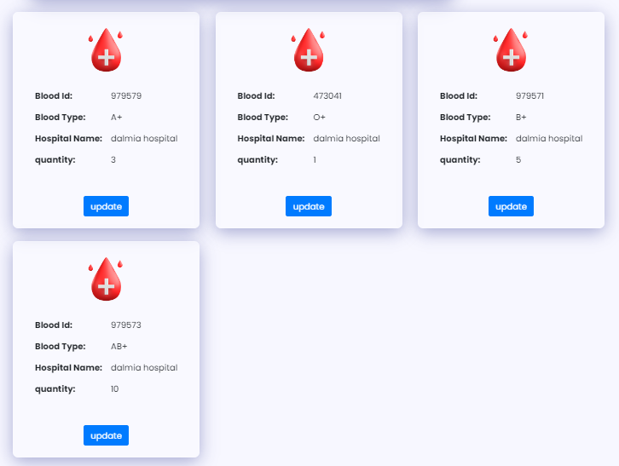

**After Approved (4 units to 3 units)**

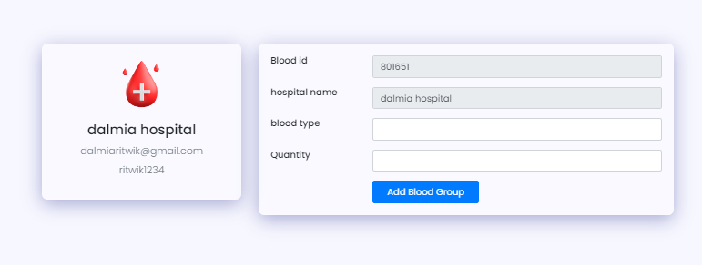

**Add Blood Group**

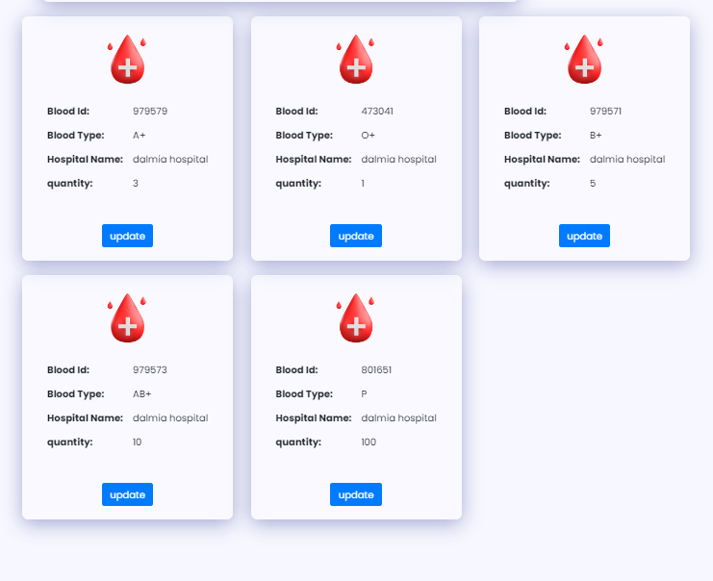

**Added Blood Group here (P)**

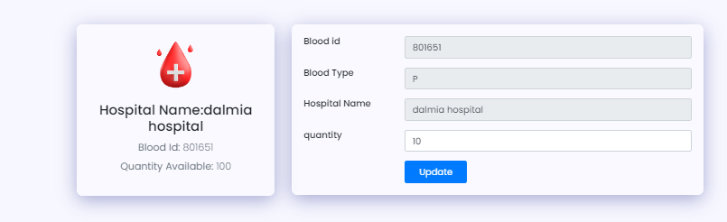

**Update the quantity/stocks p to 10 from 100**

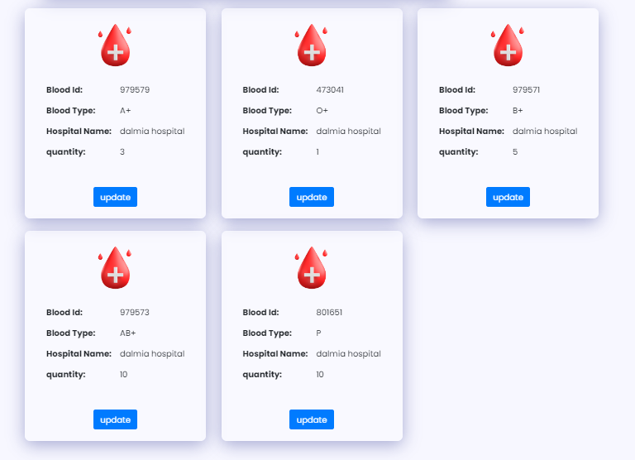

**Quantity Updated Of P to 10**

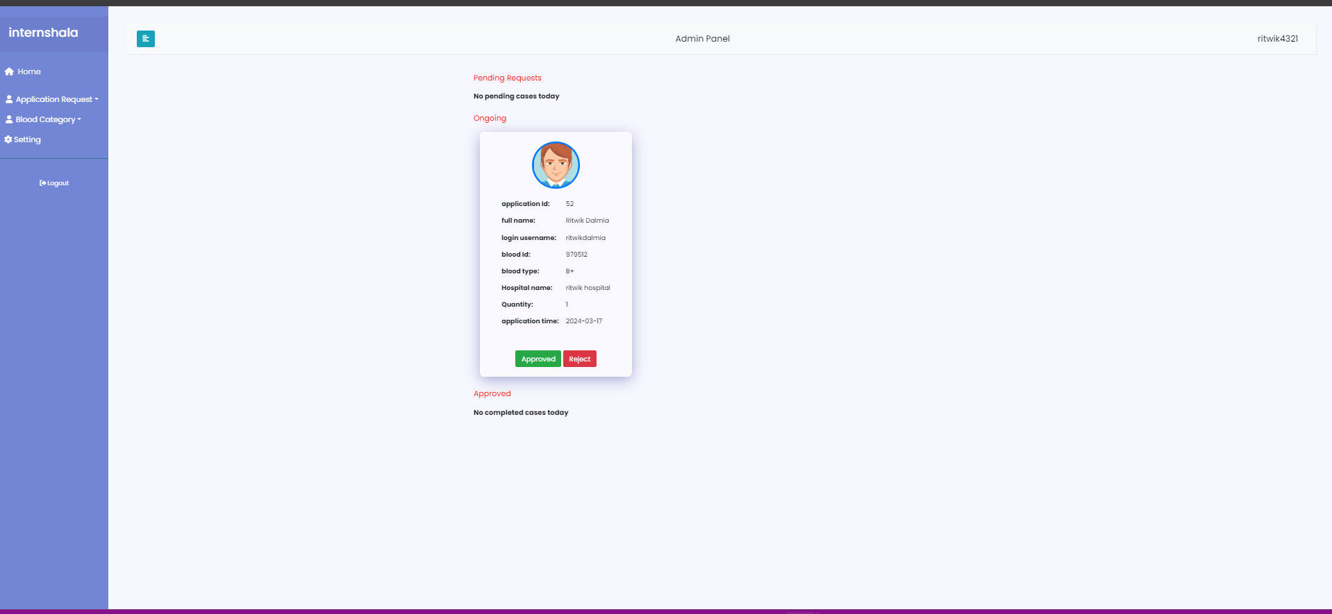

**Another Hospital (Ongoing Process)**